Retail Store Application Coverage Report

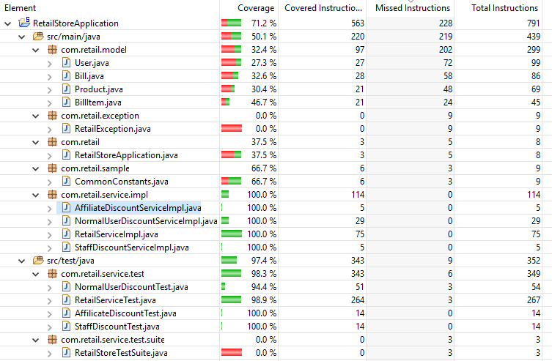

**Note:** Test case coverage is mainly focused on services